# **1.0 Objectives**

In this lab you will learn how to design and route a Printed Circuit Board (PCB). You will also learn how to export your design so it can be manufactured. You will use KiCad for these tasks as well.

# 2.0 Parts List

| **Quantity** | **Item** | |
| --- | --- | --- |
| 1 | Computer with KiCad installed | |

**NOTE: The images and instructions for this lab are valid for KiCad version 8.08 on Windows 11. Icons and button locations may change if you use a different version of the software or OS. The keyboard shortcuts that are mentioned may differ as well.**

# 3.0 Background

## 3.1 What is a Printed Circuit Boards (PCB)?

A Printed Circuit Board is the mechanical base used to hold and connect the components of an electronic circuit. PCBs use solder joints to improve the stability and reliability of the connections. Allowing for longer lasting circuits.

## 3.2 What is Routing?

Routing is the process of defining the paths or traces that connect electrical components on a printed circuit board. Routing on a PCB is the equivalent of wiring on a breadboard. Traces that are routed correctly minimize interference and ensure signal integrity.

## 3.3 Sides and Layers of a PCB

* The primary, or top, side of a PCB is where most components are mounted.
* The secondary, or bottom, side of a PCB is where few or no components are mounted. The secondary side is also known as the solder side.
* In KiCAD there are multiple layers, F.Cu refers to the layer of copper tracks connected to components on the primary or top side of the PCB. B.Cu refers to the layer of copper tracks connected to the components on the secondary or bottom side of the PCB and the Edge.Cuts Layer defines the boundary of the PCB.

# 4.0 Activity

Your task is to design and route a PCB implementation of the bus multiplexer from Lab 4. It is recommended that you watch the accompanying video before you proceed.

## 4.1 Starting a New Board Layout

* Open your project file from Lab 4. Ensure that you have completed the schematic from Lab 4 before continuing.
* From the project files double click on the file with the _pcb suffix or click on the PCB Editoricon (see Figure 1).

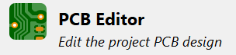

Figure 1: PCB Editor icon in the project files.

## 4.2 Getting Ready to Route

* From the drop-down list (that is highlighted in red in Figure 2), change the grid size of the PCB editor to 2.5400mm (100.00 mils). This is the standard size for a breadboard and will be important for testing your PCB.

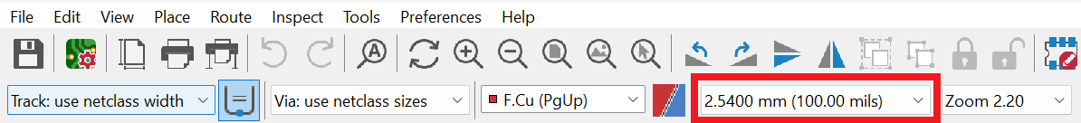

Figure 2: Top navigation bar of KiCad.

* From the Tools menu select Update PCB from Schematic or press F8 (see Figure 3). A popup window will appear. Click Update PCB and then click Close (assuming you did not get any errors). Finally, click anywhere in the main grid area. This will import the footprints and schematic from Lab 4. NOTE: if this menu item is grayed out ensure that you have accessed the PCB Editor through the project file.

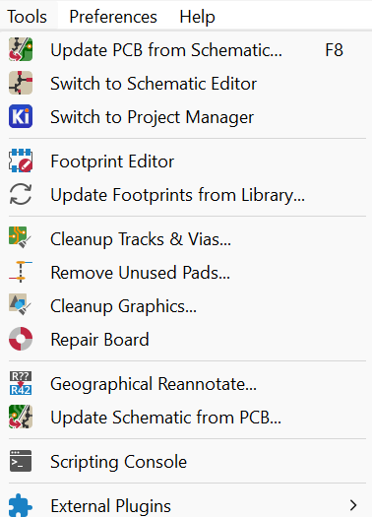

Figure 3: Top portion of the Tools menu.

### 4.2.1 Rearranging Components

* The initial placement of your components should be similar to Figure 4.
* With the grid set to 2.5400 mm, rearrange the components. Click on each of them (ensuring that the entire component is highlighted) and drag it to the appropriate position. Your finished product should look something like Figure 5.

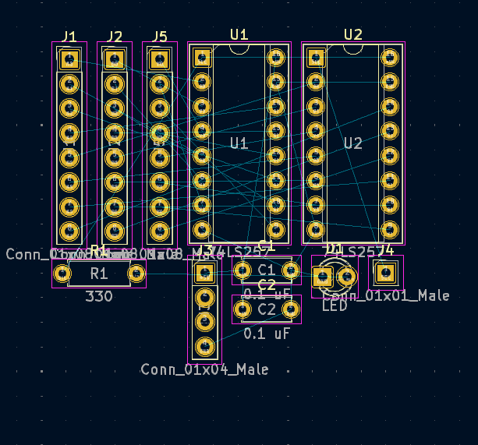

Figure 4: Default placement of components.

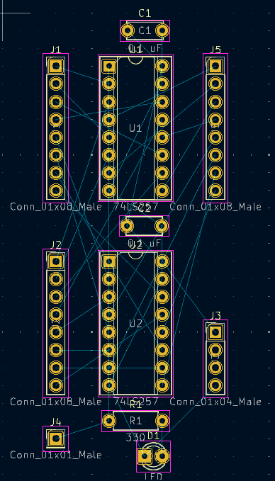

Figure 5: Desired placement of components.

### 4.2.2 Manipulating Components

* With your components rearranged, it is now time to manipulate them so they are in the correct orientation and on the correct side of the board (top or bottom).
* Select the LED and click on the Rotate Clockwise/Counterclockwisebutton(s) to rotate it clockwise by 90° (see Figure 6). Or press R on your keyboard.



Figure 6: Rotate Clockwise/Counterclockwise buttons.

* Do the same to the capacitors labeled C1 and C2, but in this case rotate them by 180°. This will make routing easier later.
* Select the input and output pins. Then, right click and select Change Side/Flip or press F on your keyboard.
* Figure 7 shows the menu with some of the keyboard shortcuts for these operations.
* After the flip, your board should look similar to Figure 8. Note that the labels for the input and output pins are now backwards, because they are now on the bottom layer. This is fine.

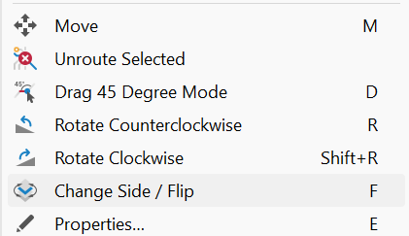

Figure 7: Common commands and their keyboard shortcuts.

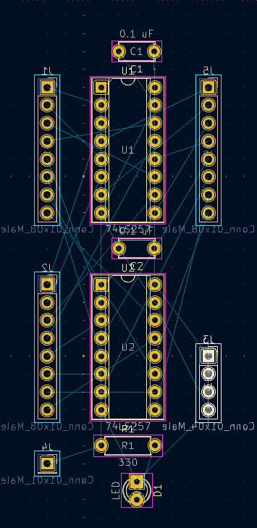

Figure 8: Top view of the board after the components have been manipulated.

### 4.2.3 Setting up Copper Fields

* To set up a copper field, locate the toolbar on the right and click on the button shown in Figure 9 or press CTRL + SHIFT + Z.



Figure 9: Add Filled Zone button.

* You will be drawing a box around your component. Start by clicking in a corner of the working area. After a second a window should appear (see Figure 10). In that window select the net to be GND and have it set for both F.Cu and B.Cu. This will ensure a copper fill linked to ground on both the front and back of the PCB.
* After clicking OK you should be able to draw the box around your components. It should look something like the outer box in Figure 11.

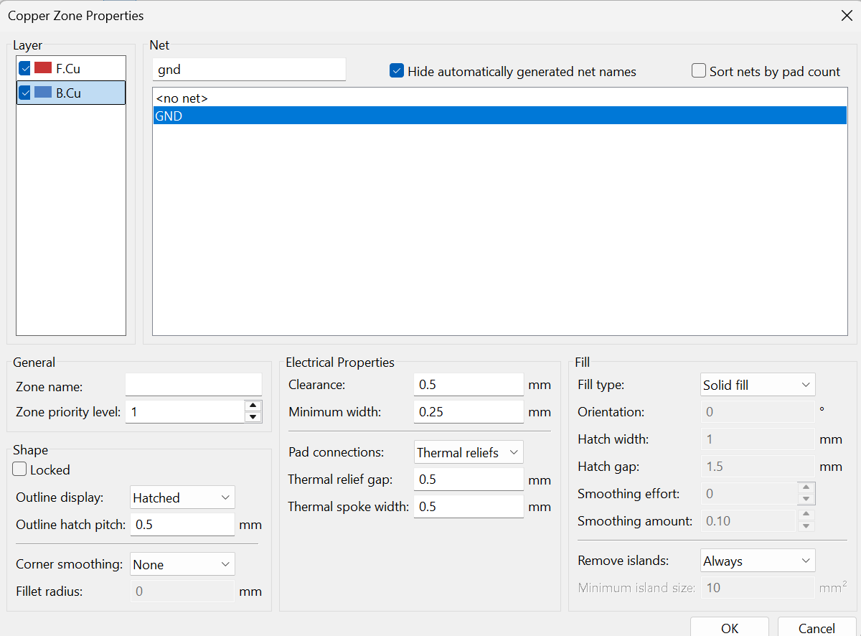

Figure 10: Copper zone properties window.

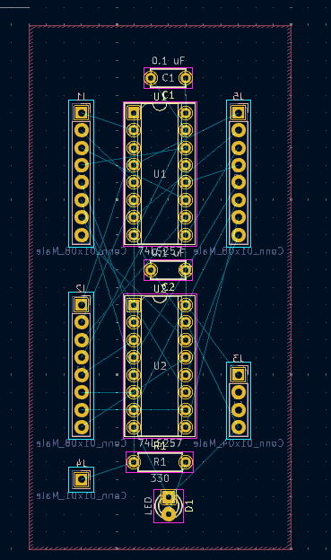

Figure 11: Rectangular copper fill surrounding all components.

### 4.2.4 Adding Through Vias

* Though vias allow you to connect the front copper wiring to the back wiring. This is a crucial step when routing a board since it allows you to simplify the wiring connections. To add through vias during the routing process, click the Add via button (see Figure 12) on the right or press Ctrl + Shift + V. Then, click on the location where you want to place the through via.



Figure 12: Add Via button.

## 4.3 Routing the Board

* You may have noticed thin blue lines connecting the pins of your components. These are called air-wires. You will be replacing these connections when routing your board.
* To route a pin select the Route Tracks button (see Figure 13) from the right menu or press X. Then, click the pin you wish to route.



Figure 13: Route Tracks button.

* You should see a highlight of where the pin needs to be connected to (see Figure 11). Simply click on the next pin in the sequence in order to route it.
* If you just click on the next pin it will just route it on the straightest path. You can manipulate the routing a bit by bringing the route around pins and components through specific routes. Refer to the tutorial video for more information.
* Additionally, you cannot cross wires on the same side so if you have a connection that crosses over another you may need to use a through via to complete the connection.
* At this point it is ok to change the grid size in the top menu from 2.5400mm (100.00 mils) to something smaller to allow for finer control over the routing. Just make sure that you don’t accidentally move the components from where you had placed them when the grid was set to the correct size.

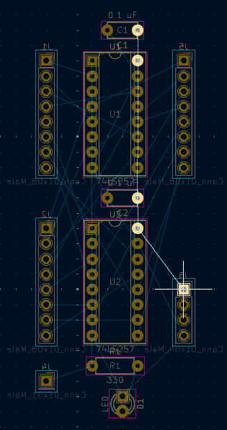

Figure 14: Highlighted air-wires.

* There are many different ways of routing a board. So, your implementation may differ from this guide. For step-by-step instructions on routing see the tutorial video.
* Your finished product should look something like Figure 15.

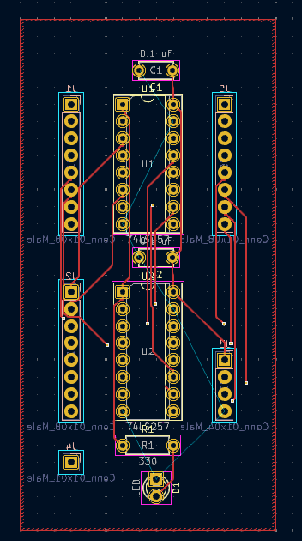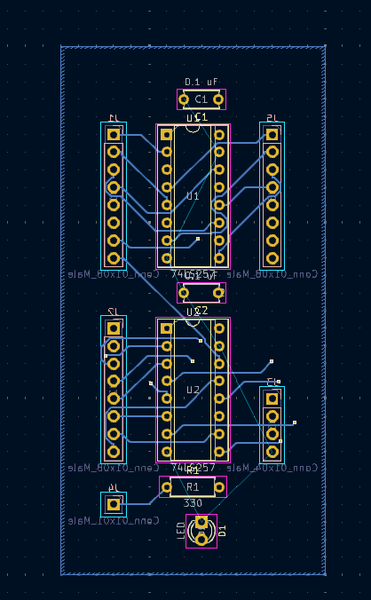

a. Front side routed b. Back side routed

Figure 15: Routed PCB implementation.

## 4.4 Labeling and Final Touches

### 4.4.1 Adding a Rectangle

* Using the Draw a Rectangle button (see Figure 16) from the right toolbar, draw a rectangle around your components. It should be inside the rectangle that you drew for the copper field in the Edge.Cuts layer.



Figure 16: Draw Rectangle button.

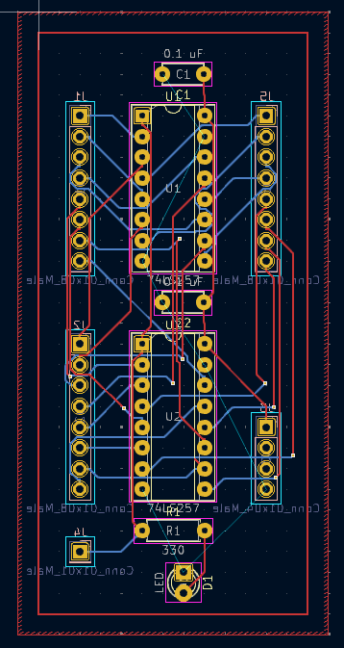

Figure 17: Implementation with Edge.Cuts box drawn.

### 4.4.2 Labeling Your Board

* You may have noticed that some of the labels are flipped to be on the backside. To correct this, start by selecting the labels so that only they are highlighted. Then select Change Side/Flip or press F to ensure that all labels are on the front.
* Next, select the labeling for the capacitors C1 and C2 so that they are highlighted. Move them to the left of the component so that they are not overlapping the labels for the Mux chips.
* Add labels for the Control pin, Select line, input voltage, GND, CLK and RST by selecting Add Text from the place menu or clicking Ctrl + Shift + T (see Figure 18).

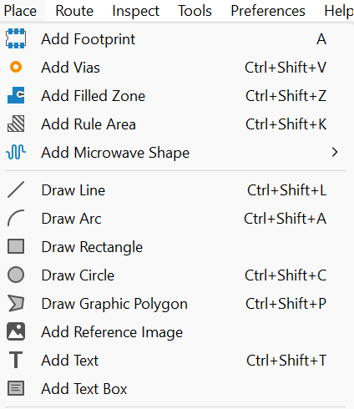

Figure 18: Items in the Place menu.

* Click anywhere with that setting selected and add text as shown in Figure 19.

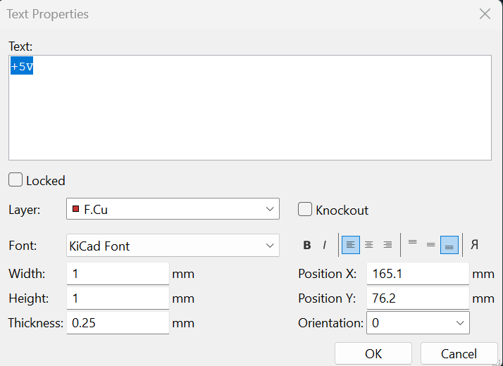

Figure 19: Text properties window.

* In the top-left corner of your board add the text “T##_LX”, where ## is your team number and X is your lab section. This will be used to identify your board when it arrives from the manufacturer.
* Finally, select the copper field you had placed earlier. From the Edit menu select Fill All Zones or press B (see Figure 20). This will fill in your copper field and adjust it to the routes that you have made.

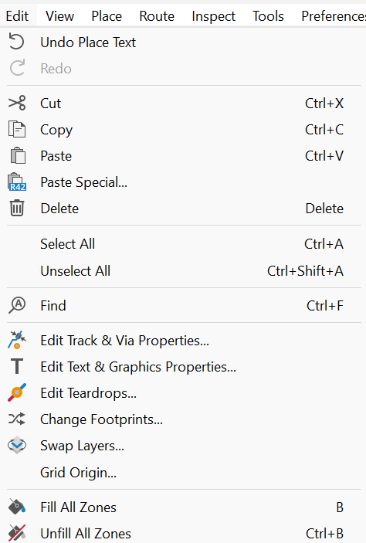

Figure 20: Items in the Edit menu.

* Your final product should look something like Figure 21. Figure 22 shows a more detailed front and back view of the finished product.

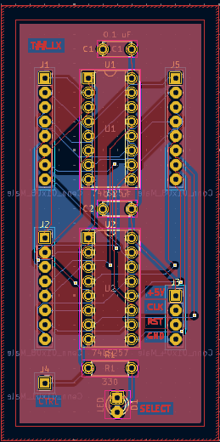

Figure 21: Finished design of a routed board.

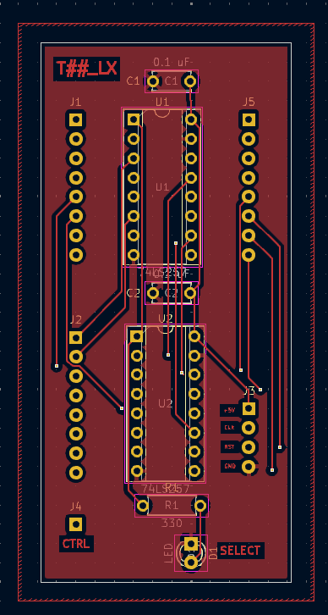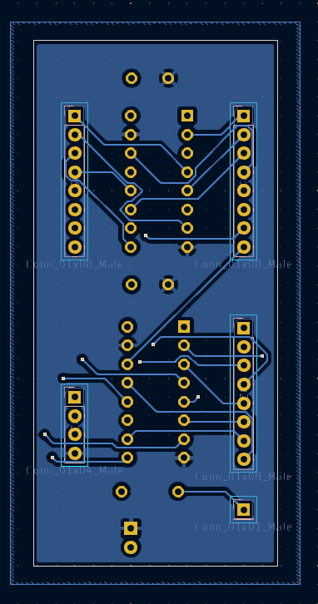

Figure 22: Front and back views of Finished Circuit board.

**4.5 Viewing the PCB in 3D**

* KiCAD allows you to view a rendered 3D version of what your board will look like.
* To view this rendering click on the 3D Viewer button (see Figure 23).



Figure 23: Icon for 3D Viewer button.

* This will open up the 3D viewer window in which you should be able to see and rotate the rendered version of your PCB (see Figure 24).
* You may notice that in the 3D render window the MUX chips show up as sockets. This is because the footprint in the schematic used a socket rather than a chip. The holes made by the socket will later also fit a chip so that the chip could be soldered directly to the PCB or inserted into a socket that is soldered to the board.

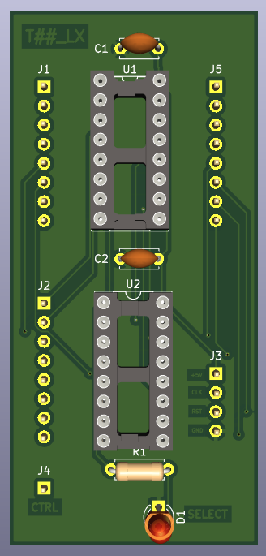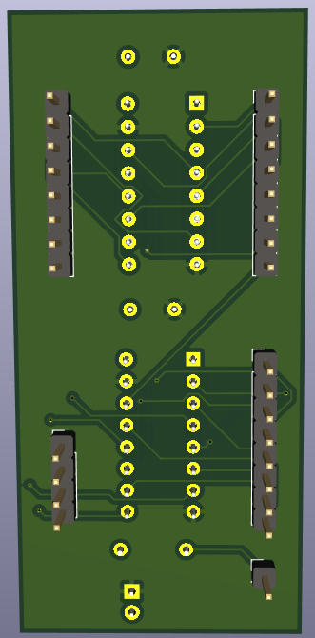

Figure 24: Finished design of a routed board.

## 4.6 Exporting the Gerber Files

* You are finished with designing your board. Congratulations! Now it is time to export the design so it can be manufactured.
* Run the Design Rules Checker (DRC) from the top menu (see Figure 25). This will check for any errors in your PCB design. If it finds any issues, they must be resolved before exporting to a gerber file.



Figure 25: Run DRC button.

* To export your board, go to the File menu, hover over Fabrication Outputs, and click Gerbers (.gbr) (see Figure 26).

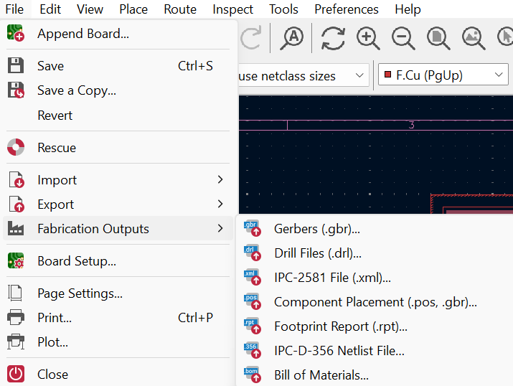

Figure 26: File menu options with fabrication outputs shown.

* Select the appropriate output directory at the top and match the settings and options shown in Figure 27. Click Plot to output the first set of files.

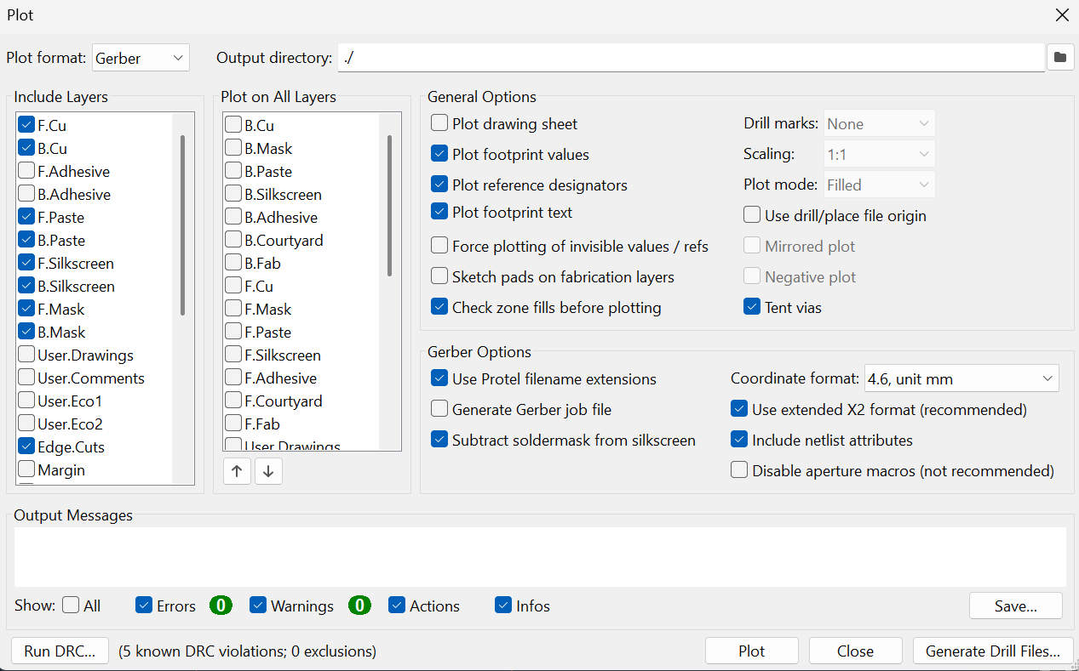

Figure 27: Plot window with desired settings.

* Next, click Generate Drill Files and set the options to match Figure 28. Click Generate Drill File to output the appropriate files.

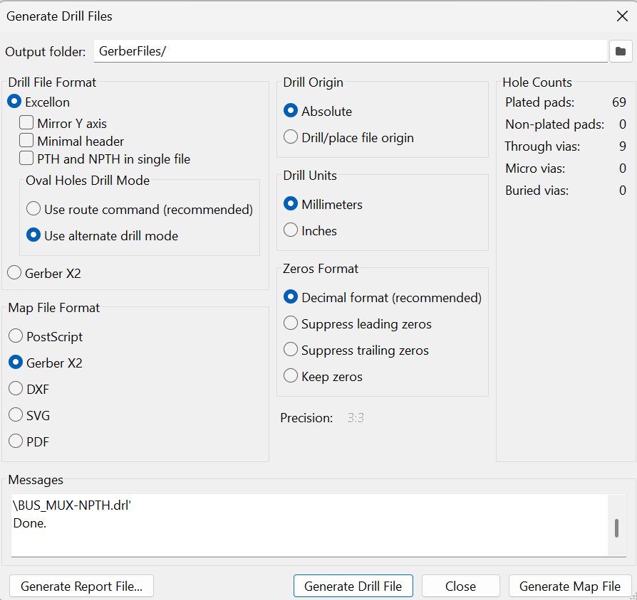

Figure 28: Generate Drill Files window.

* The output folder now has a zip file that contains all files necessary to manufacture your board.
* Submit this zip file along with your lab report.